Go Green Park Ridge Rain Barrel Consultation

What’s a rain barrel?
Rain barrels collect the rainwater that runs off your roof which can then be used to irrigate landscaping, wash your car or fill ponds and fountains.
Rain barrels are a great way to conserve water!

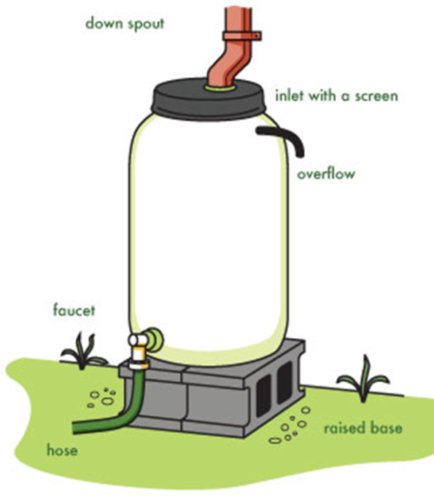
Visit www.gogreenparkridge.org for more details or
email parsonchris@hotmail.com to set up a consultation appointment for your rain barrel.

