Creating A Pollinator Partnership In Park Ridge Churches

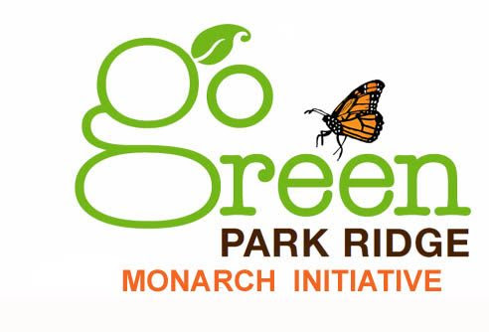
Background: The Monarch butterfly has been listed as a threatened species under the Endangered Species Act and is the Illinois State insect. The loss of monarchs has been due in part to the loss of habitat and food sources for the caterpillar that feeds only on milkweed species (Asclepias sp.). Milkweed at one time grew throughout the Midwest. Today in Illinois there is only 1/10th of one percent of tall grass prairie remaining.

Goal: By planting milkweed in existing flower beds in our various church spaces we can help in the recovery of the Monarch butterfly – a deep and powerful symbol of life.

Objective: The monarch initiative aims to increase the amount of milkweed grown in Park Ridge. Through extensive community outreach, Go Green Park Ridge is engaging with various organizations and individuals in the planting of native milkweed species in 2016.

How: Milkweed seedling growing, distribution, and plantings will occur through partner volunteer based organizations, commercial growers, and the Illinois extension service. Partnering churches can bring this activity about in a unique, hands-on approach with their own congregations. Once an outdoor space is designated and formally approved by a church(s), Go Green Park Ridge may be able to provide a limited number of volunteers to assist in planting.

Our Terms: Partnering churches would need to provide a cleared garden spot for growing the milkweed and designate a steward for the plantings in the first year’s growing season. After a full year of growth is complete, the milkweed shall be established and independent. There can be no pesticide spraying on the milkweed plants or the nearby nectar plants.

Outcome: Multiple plantings in public spaces, parks, schools, library and city hall can serve as a demonstration and educational tool to further engage the community in conservation. Signage is another learning piece to this monarch initiative and is being explored.

Together We Can Make Conservation Meaningful In Park Ridge!
“Let the heavens be glad, and let the earth rejoice!” Psalm 96:11-12

If interested please email: gogreenparkridge@gmail.com
www.gogreenparkridge.org

backyardbutterflies.com

