Creating A Pollinator Partnership With Park Ridge Businesses

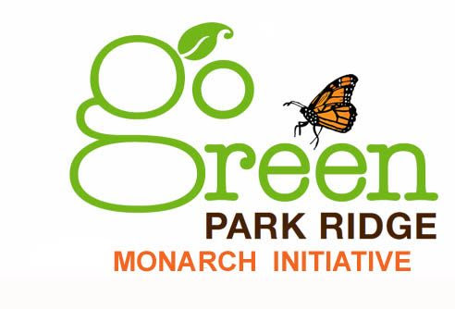

Here’s how your business can become a part of increasing the Monarch Butterfly Population in Park Ridge:

Background: The Monarch butterfly has been listed as a threatened species under the Endangered Species Act and is the Illinois State insect. The loss of monarchs has been due in part to the loss of habitat and food sources for the caterpillar that feeds only on milkweed species. Milkweed at one time grew throughout the Midwest.

Goal: Planting milkweed can help in the recovery of the Monarch butterfly – a deep and powerful symbol of life.

How: The monarch initiative aims to increase the amount of milkweed grown in Park Ridge. Go Green Park Ridge plans to distribute 500 FREE milkweed seedlings, seed balls, and dried seed packets at area events.

Condition: Partnering businesses can help fund our initiative. Your $25 donation can earn a spot for your business logo on our Go Green Park Ridge website. Larger donations will be considered as an additional sponsorship opportunity and will be added to our seedling and seed packet handouts to the public.

Outcome: Multiple plantings of milkweed in our town will further engage the community in conservation efforts and will also help restore and enhance the thousands of acres of habitat across the nation. Your logo on printed materials for the monarch initiative tells Park Ridge that you care about our common home. A huge thank you to Pizzo and Associates, Ltd. and Bono Consulting, Inc. for getting this project jumpstarted!

FREE Millkweed Distribution Dates: Park Ridge Community Showcase at Library 4/16 MANNA Day of Service 4/24, Park Ridge Park District Earth Day Celebration 4/30, St Paul of the Cross 5/21, Park Ridge Farmers Market 6/4, Monarch Presentation at Library 6/9, Park Ridge Garden Walk 6/26

Contact: gogreenparkridge@gmail.com
www.gogreenparkridge.org

backyardbutterflies.com

